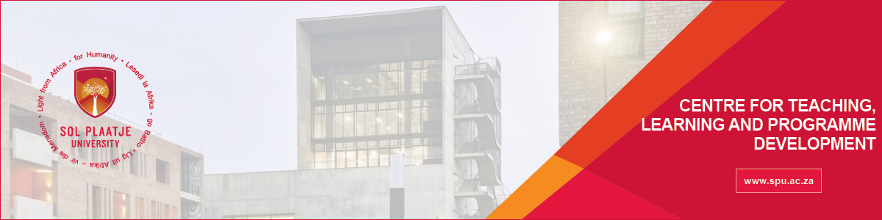
The Centre for Teaching, Learning and Programme Development (CTLPD)
Are you looking for an opportunity to develop professionally and personally- Apply to become an Academic Facilitator (2024)
The role will develop critical thinking, reasoning, problem-solving, oral and written communication skills, digital competencies, and an entrepreneurial mindset.
The academic facilitator supports first-year students in developing Academic and Digital Literacies to ensure a seamless transition into and through the academic year.
To apply, you need the following competencies:
- Degree in Education/Humanities or related field to teaching assistant responsibilities
- Registered Postgraduate qualification in 2024 (e.g., Honours or Masters)
- Proficiency in English (oral and written)
- Good interpersonal and communication skills
- Time management skills
- Ability to navigate Moodle and MS Teams
- Ability to work in a team and independently
- Empathetic, helpful and supportive towards others
- Ability to work respectfully with diverse cultures, backgrounds, perspectives, and abilities
- Experience working with students will be advantageous (e.g. peer mentor or tutor)
The duties and responsibilities of an Academic Facilitator include the following:
- Monitor and nurture students’ academic literacy development;
- Prepare and present academic literacy facilitation sessions.
- Prepare and facilitate undergraduate academic writing support (group, individual and workshops)
- Retrieve and analyse student activity reports and conduct follow-up meetings with students;
- Provide academic writing support for all students;
- Invigilate SCOR integrated assessment
- Provide assessment feedback to students and Lecturers;
- Monitor and keep a record of attendance registers and student progress.
Please apply at https://forms.office.com/r/qmJYJdLt0W on/before 22 February 2024. Your CV will be reviewed, and you will receive an invitation to complete a selection test, if successful, you will be invited to the interview. Please consider your application unsuccessful if you do not receive any communication by 26 February 2024.

